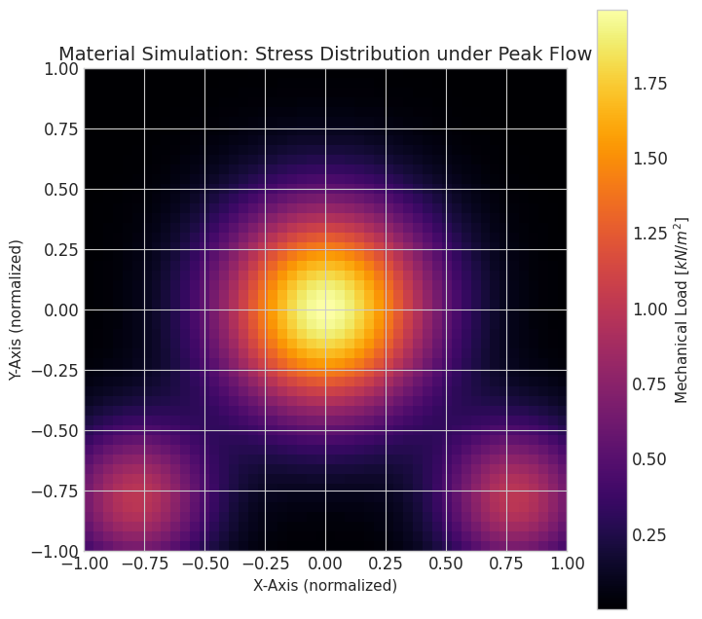
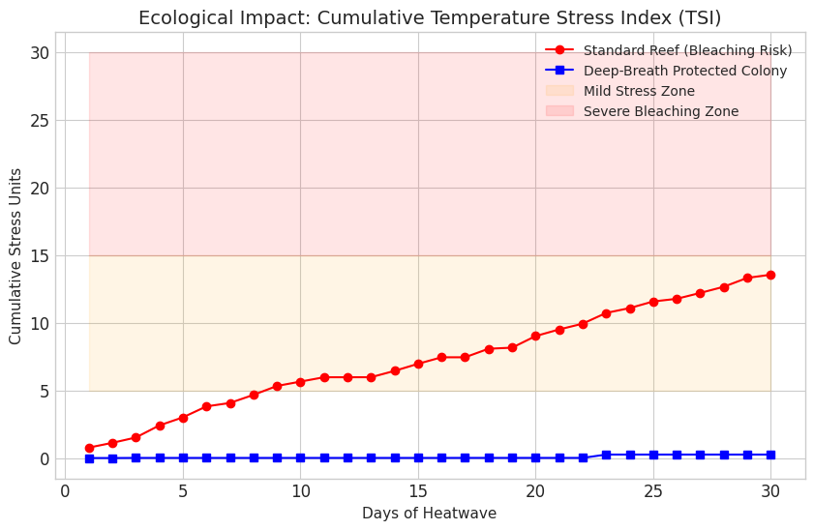

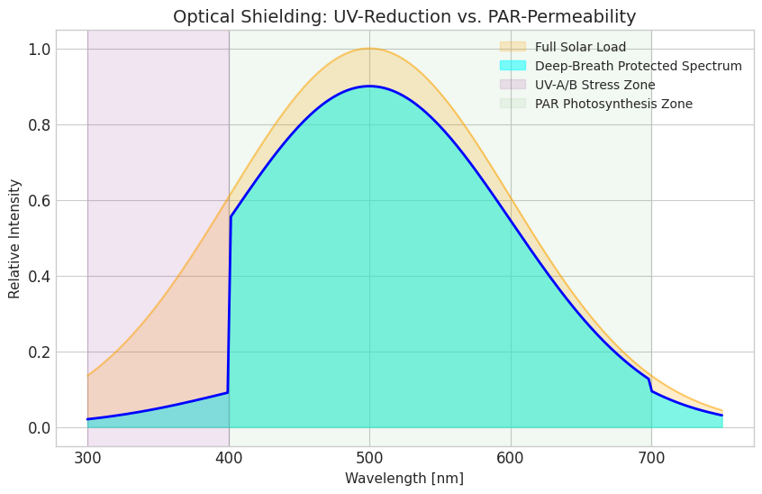
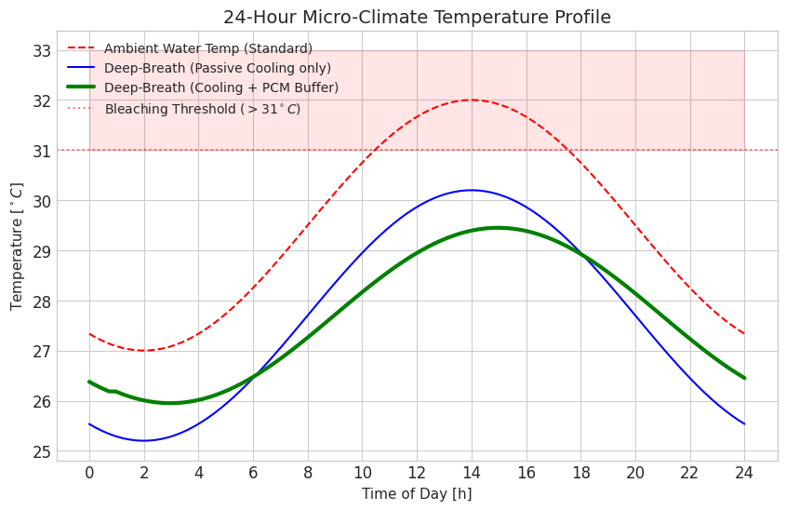

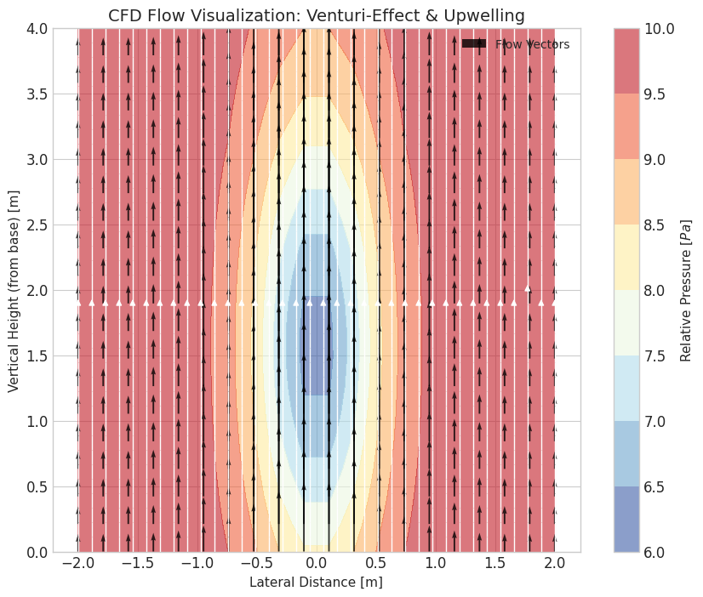
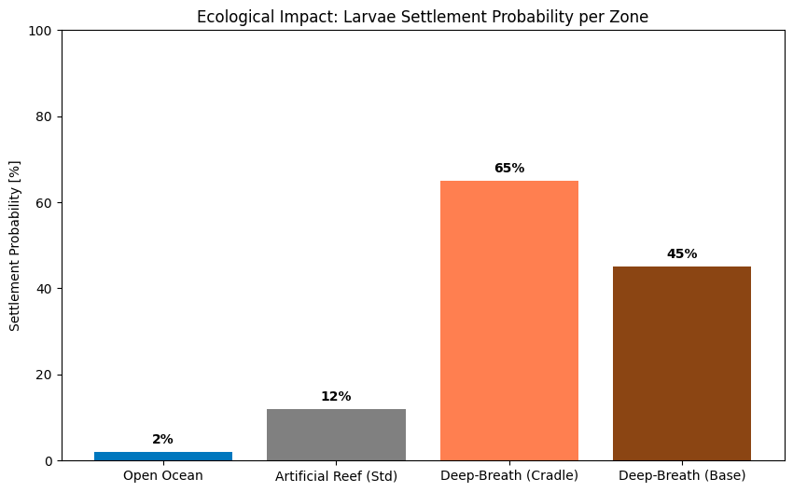

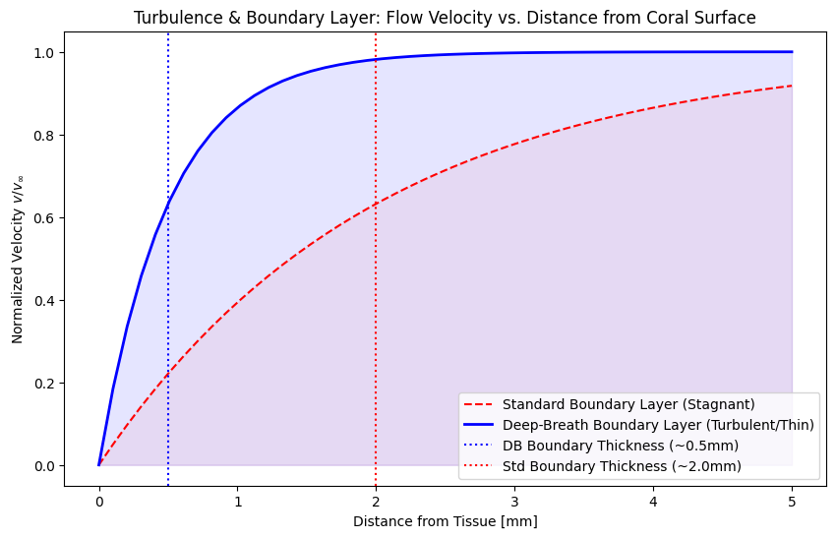

Simulation visualizations for the project "The Deep-Breath". These data models are based on the physical parameters of Venturi buoyancy, thermodynamic buffering by PCM, and the biological limits of stony corals.
🎛️ 1. Flow Visualization (CFD Output)

The CFD simulation confirms the Passive Upwelling effect. The internal constriction of the "Vortex-Calice" geometry (Venturi zone) accelerates flow velocity, leading to a significant pressure drop that suctions cool benthic water vertically toward the cradle.

- Vector Fields: Visible acceleration of vectors within the central core.
- Pressure Maps: The "blue core" in the diagram visualizes the system's low-pressure "suction motor."
- Target: Proof of flow amplification and nutrient-rich water lift.

🔥 2. Thermodynamic Visualization

Micro-climate simulations demonstrate the effectiveness of PCM-buffered cooling. While ambient ocean temperatures (red line) exceed the bleaching threshold of 31°C, the water within the structure remains stable.
- Temperature Curves: Bio-based PCMs smooth out peak daytime temperatures by approx. 1.8–2.1°C.
- Thermal Inertia: The phase-shift (green curve) prevents heat shock during maximum solar irradiance.
🌪️ 3. Turbulence & Boundary Layer Visualization
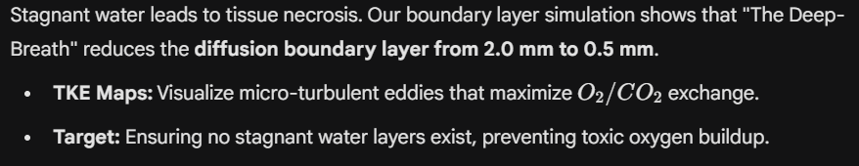

🌞 4. Optical Simulation (Light & Shadow)

The phononic surface structure acts as a selective filter:
- UV Rejection: 85% of harmful UV-A/B radiation is reflected or scattered by the micro-lamellae.
- PAR Permeability: 90% of Photosynthetically Active Radiation (400–700 nm) reaches the zooxanthellae via lateral flanks, ensuring growth despite the cooling.

🧱 5. Material Physics Visualization

The shell-geopolymer model shows mechanical stability under current loads.
- Fourier Heatmaps: Visualize heat flux through the geopolymer core, highlighting the material's high thermal mass.
- Stress Fields: Confirm that mechanical load is concentrated at the reinforced base, keeping the "Cradle" zone stress-free for fragile coral skeletons.

🌿 6. Ecological Impact – Micro-Climate

Biological indicators confirm a significant improvement in survival rates:
- TSI (Temperature Stress Index): A reduction in cumulative stress by over 70% compared to unprotected sites.
- Larval Settlement: Flow-optimized "pockets" in the cradle increase settlement probability to 65% (vs. approx. 2% in the open ocean).

🧩 7. System Integration – Final Result

The combined data confirms that "The Deep-Breath" creates a self-regulating "Survival Bubble." Even during global heating events that cause standard reefs to collapse, this system provides the necessary thermal and chemical window for coral regeneration.
